**29**

**Sources of the Magnetic Field**

|  |
| --- |
| **CHAPTER OUTLINE** |

29.1 The Biot–Savart Law

29.2 The Magnetic Force Between Two Parallel Conductors

29.3 Ampère’s Law

29.4 The Magnetic Field of a Solenoid

29.5 Gauss’s Law in Magnetism

29.6 Magnetism in Matter

* An asterisk indicates a question or problem new to this edition.

|  |
| --- |
| **ANSWERS TO THINK – PAIR – SHARE PROBLEMS** |

**\*TP29.1**. **Conceptualize** Consider the short section of length *dx* located at position *x* in Figure TP29.1. It acts as a circular loop of current. The total current in the loop is *NI*, where *I* is the current in each turn, and *N* is the number of turns in the length *dx*: *N* = *n* *dx*. The total magnetic field at *P* will be the sum of the magnetic fields due to all such current loops in the solenoid.

**Categorize** The Conceptualize step helps us to categorize the problem as an integration over a current distribution.

**Analyze** (a) Modify the result of Example 29.3 to represent the contribution *dB* to the magnetic field at *P* from the current loop in the short length *dx* of the solenoid:

 (1)

Find the total magnetic field at *P* by integrating Equation (1) over the length of the solenoid:

 (2)

To simplify the integral, define *s* = *d* – *x*, so that *ds* = –*dx*:

 (3)

Use Table B.5 in the Appendix to perform the integration:



(b) Now, to find the field at the midpoint of the solenoid, let *d* → 0 in Equation (4):



(c) Now, to find the field of an infinitely long solenoid, let  → ∞ in Equation (5):

 (6)

(d) Equation (6) is identical to Equation 29.17.

**Finalize** Let’s try another limit. If  goes to zero, does Equation (4) reduce to the field of a single loop of current? Let’s try it:



Oops. That didn’t work. Shrinking the solenoid to zero length takes away *all* current loops, so there is no source of the field.]

*Answers:* (a) 

(b) 

(c) 

(d) It is the same.

**\*TP29.2** (a) The answer will depend on the size of the nail, the gauge of the wire, and the terminal voltage of the battery. Given typical nails, wire, and batteries, a small number of paper clips should be suspended.

(b), (c) The number of paper clips suspended will grow, but will likely not grow linearly with the number of turns of wire. As more turns are added, the domains in the nail may reach a point where no more can be aligned with the field, so adding more turns increases the effect of the solenoid of wire, but not the effect of the ferromagnetism of the nail. The results from the 8-turn, 10-turn, 12-turn, and 14-turn experiments, however, may allow you to make an estimate of the number suspended for 20 turns.

(d) Assuming that the second layer of turns continues in the same direction around the nail, the number of turns per unit length, *n* in Equation 29.17, is doubled. Therefore, the magnitude of the magnetic field due to the solenoid is increased, and the apparatus should suspend more paper clips than it does with a single layer of 10 turns.]

*Answer:* Answers will vary.

|  |
| --- |
| **SOLUTIONS TO END-OF-CHAPTER PROBLEMS** |

Section 29.1 The Biot–Savart Law

**P29.1** The magnetic field is given by



**\*P29.2** **Conceptualize** The power line will act as a source of magnetic field that will combine with the Earth’s magnetic field to determine the direction of the compass reading. Because the power line is running north–south, the magnetic field lines from the power line at the location on the ground will be oriented along an east–west direction.

**Categorize** We model the power line as a long, straight wire that is carrying a current.

**Analyze** (a) The magnitude of the magnetic field from the power line is given by Equation 29.5:

 (1)

Substitute numerical values to find the magnitude of the magnetic field at the point on the ground directly below the power line:



(b) In Table 28.1, we see that the magnitude of the Earth’s magnetic field is 5 × 10–5 T. Therefore, the magnetic field from the power line is about 8% as strong as that from the Earth. This is sufficient to cause an error in the compass reading that would have sent the hiker off in a different direction than expected. Therefore, the error was caused by the operator of the compass by taking a reading under a power line, and is not caused by a defect in the compass.

**Finalize** While the magnetic field of the Earth is not directed due north in many areas, and also has a vertical component, let us assume that the field is due north and horizontal in order to get an estimate of the error caused by the power line. The vector expression, then, for the total magnetic field at the location of the compass is (assuming the field from the power line is directed east),



where the *x* direction is east and the *y* direction is north. From our discussion of vectors in Chapter 3, we can determine that this vector is of magnitude 5.02 × 10–5 T and is directed 4.6° east of north. This unexpected angle of 4.6° could cause a hiker to be quite far from the intended destination after walking a long distance.

*Answer:* (a) 4.06 × 10–6 T (b) The error was caused by the operator of the compass by taking a reading under a power line, and is not caused by a defect in the compass.

**P29.3** Treat the magnetic field as that produced in the center of a ring of radius *R* carrying current *I*: from Equation 29.8, the field is  The current due to the electron is



so the magnetic field is



**P29.4** The vertical section of wire constitutes one half of an infinitely long, straight wire at distance *x* from *P*, so it creates a field equal to



Hold your right hand with extended thumb in the direction of the current; the field is away from you, into the paper.

For each bit of the horizontal section of wire  is to the left and  is to the right, so  The horizontal current produces zero field at *P*. Thus,



**P29.5** Every element of current creates magnetic field in the same direction, into the page, at the center of the arc. The upper straight portion creates one-half of the field that an infinitely long straight wire would create. The curved portion creates one-quarter of the field that a circular loop produces at its center. The lower straight segment also creates field .

The total field is



**P29.6** Along the axis of a circular loop of radius *R*,



or 

where 

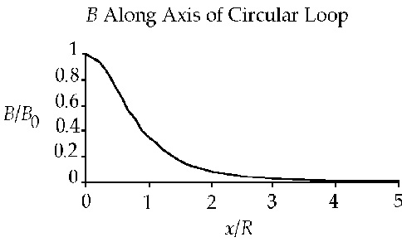  
**ANS. FIG. P29.6**

|  |  |
| --- | --- |
| *x*/*R* | *B*/*B*0 |
| 0.00 | 1.00 |
| 1.00 | 0.354 |
| 2.00 | 0.089 4 |
| 3.00 | 0.031 6 |
| 4.00 | 0.014 3 |
| 5.00 | 0.007 54 |

**P29.7** Label the wires 1, 2, and 3 as shown in ANS. FIG. P29.7(a) and let the magnetic field created by the currents in these wires be  respectively.

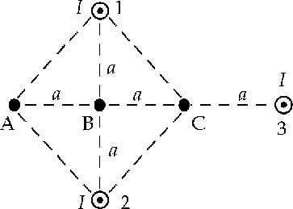

**ANS. FIG. P29.7(a)**

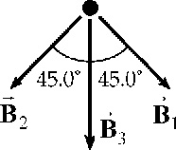

**ANS. FIG. P29.7(b)**

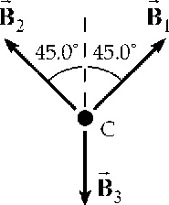

**ANS. FIG. P29.7(c)**

(a) At point *A*:



and 

The directions of these fields are   
shown in ANS. FIG. P29.7(b).  
Observe that the horizontal  
components of  and  cancel   
while their vertical components   
both add onto Therefore, the   
net field at point *A* is:





(b) At point *B*:  and  cancel, leaving



(c) At point *C*: and  with the directions shown in ANS. FIG. P29.7(c). Again, the horizontal components of  and  cancel. The vertical components both oppose  giving



**P29.8** (a) Above the pair of wires, the field out of the page of the 50.0-A current will be stronger than the  field of the 29.0-A current, so they cannot add to zero. Between the wires, both produce fields into the page. They can only add to zero below the wires, at coordinate *y* = –⎮*y*⎮. Here the total field is

 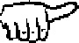  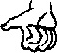:



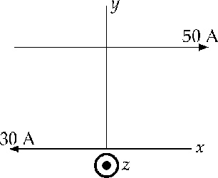

**ANS. FIG. P29.8**

(b) At *y* = 0.100 m the total field is

 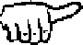  :



The force on the particle is



(c) We require 

so 

**P29.9** Apply the Equation 29.4, , to each of the wires. For the horizontal wire (*H*), and  because  measures to the wire’s end point on the –*x*-axis and  measures to the wire’s end point on the +*x*-axis. For the left vertical wire (*VL*) and the right vertical wire (*VR*),  and sin = 1 because both angles measure to the wire’s end points on the +*y*-axis.

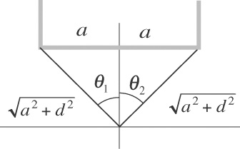

**ANS. FIG. P29.9**

Take out of the page as the positive direction, and into the page as the negative direction. The field at the origin is



The field is negative: magnetic field at the origin is  into the page.

**P29.10** (a) We use Equation 29.4 in the chapter text for the field created by a straight wire of limited length. The sines of the angles appearing in that equation are equal to the cosines of the complementary angles shown in our diagram.

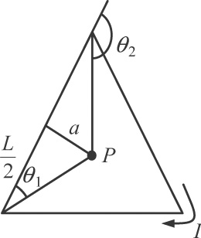

**ANS. FIG. P29.10 (a)**

For the distance *a* from the wire to the field point we have , *a* = 0.288 7*L*. One wire contributes to the field at *P*



Each side contributes the same amount of field in the same direction, which is perpendicularly into the paper in the picture. So the total field is .

(b) As we showed in part (a), one whole side of the triangle creates field at the center . Now one-half of one nearby side of the triangle will be half as far away from point *P*b and have a geometrically similar situation. Then it creates at *P*b field



The two half-sides shown crosshatched in the picture create at *P*b field



The rest of the triangle will contribute somewhat more field in the same direction, so we already have a proof that the field at *Pb* is .

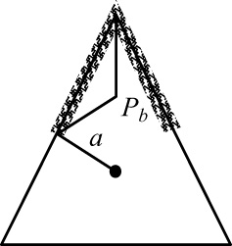

**ANS. FIG. P29.10 (b)**

**P29.11** Call the wire carrying a current of 3.00 A wire 1 and the other wire 2. Also, choose the line running from wire 1 to wire 2 as the positive *x* direction.

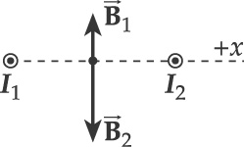

**ANS. FIG. P29.11 (a)**

(a) At the point midway between the wires, the field due to each wire is parallel to the *y*-axis and the net field is



Thus,



or 

(b) Refer to ANS. FIG. P29.11 (b). At point *P*,  and *B*1 is directed at  = +135°. The magnitude of *B*1 is



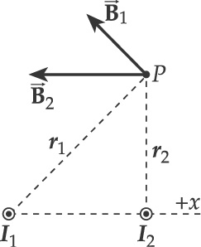

**ANS. FIG. P29.11 (b)**

The contribution from wire 2 is in the –*x* direction and has magnitude



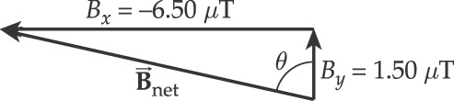

**ANS. FIG. P29.11 (c)**

Therefore, the components of the net field at point *P* are:



and



Therefore,



at 

in ANS. FIG. P29.11 (c), which is 77.0° + 90.0° = 167.0° from the positive *x* axis. Therefore,

.

Section 29.2 The Magnetic Force Between Two Parallel Conductors

**P29.12** (a) The force per unit length that parallel conductors exert on each other is, from Equation 29.12, . Thus, if , *I*1 = 5.00 A, and *d* = 4.00 cm, the current in the second wire must be



(b) Since parallel conductors carrying currents in the same direction attract each other (see Section 29.2 in the textbook), the currents in these conductors which repel each other must be in 

(c) From Equation 29.12, the force is directly proportional to the product of the currents. The result of reversing the direction of either of the currents and doubling the magnitude would be that the   


**P29.13** (a) From Equation 29.12, the force per unit length that one wire exerts on the other is , where *d* is the distance separating the two wires. In this case, the value of this force is



(b) We can answer this question by consulting Section 29.2 in the textbook, or we can reason it out. Imagine these two wires lying side by side on a table with the two currents flowing toward you, wire 1 on the left and wire 2 on the right. The right-hand rule that relates current to field direction shows the magnetic field due to wire 1 at the location of wire 2 is directed vertically upward. Then, the right-hand rule that relates current and field to force gives the direction of the force experienced by wire 2, with its current flowing through this field, as being to the left, back toward wire 1. Thus, the force one wire exerts on the other is an  force.

**P29.14** Carrying oppositely directed currents, wires 1 and 2 repel each other. If wire 3 were between them, it would have to repel either 1 or 2, so the force on that wire could not be zero. If wire 3 were to the right of wire 2, it would feel a larger force exerted by 2 than that exerted by 1, so the total force on 3 could not be zero. Therefore wire 3 must be to the left of both other wires as shown. It must carry downward current so that it can attract wire 2. We answer part (b) first.

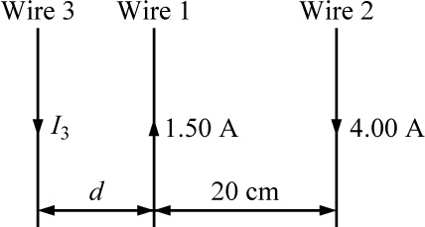

**ANS. FIG. P29.14**

(b) For the equilibrium of wire 3 we have



1.50(20.0 cm + *d*) = 4.00*d*



(a) Thus the situation is possible in just one way.

(c) For the equilibrium of wire 1,





We know that wire 2 must be in equilibrium because the forces on it are equal in magnitude to the forces that it exerts on wires 1 and 3, which are equal because they both balance the equal-magnitude forces that 1 exerts on 3 and that 3 exerts on 1.

**\*P29.15** **Conceptualize** The repulsive force between the wires will cause them to move apart until it is balanced by the inward spring forces.

**Categorize** Each of the wires is modeled as a *particle in equilibrium.*

**Analyze** Set up the force equation in the particle in equilibrium model:

 (1)

Substitute for the magnetic and spring forces:

 (2)

where we have recognized that there are two springs. Solve Equation (2) for *k*:



**Finalize** This is the expression requested. Notice that the procedure is very sensitive to a proper measurement of *d*, since *d* appears to the second power in the expression for *k*.

*Answer:* 

**P29.16** From Equation 29.16, we find the separation distance between the wires as



Substituting numerical values,



This is the required center-to-center separation distance of the wires, but the wires cannot be this close together. Their minimum possible center-to-center separation distance occurs if the wires are touching, but this value is 2*r* = 2(250 *μ*m) = 500 *μ*m, which is much larger than the required value above. We could try to obtain this force between wires of smaller diameter, but these wires would have higher resistance and less surface area for radiating energy. It is likely that the wires would melt very shortly after the current begins.

**P29.17** This is almost a standard equilibrium problem involving tension, weight, and a horizontal repulsive force; however, here we must consider the magnetic force per unit length and the weight per unit length. The tension makes an angle *θ*/2 = 8.00° with the vertical. The mass per unit length is *λ* = *mg*/*L*. The separation between the wires is .

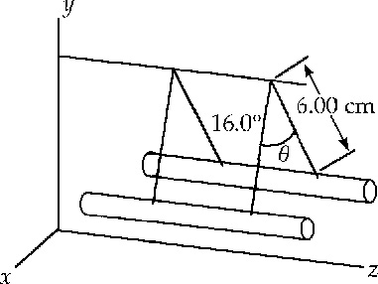

**ANS. FIG. P29.17**

(a) Because the wires repel, the currents are in 

(b) For balance, the ratio of the horizontal tension component   
*T* sin *θ*/2 to the vertical tension component *T* cos *θ*/2 is equal to the ratio of the horizontal magnetic force per unit length  to the vertical weight per unit length 



But,



Rearranging and substituting gives



Solving,





(c) 

Section 29.3 Ampère’s Law

**P29.18** From  

**P29.19** (a) 

(b) 

**P29.20** By Ampère’s law, the field at the position of the wire at distance *r* from the center is due to the fraction of the other 99 wires that lie within the radius *r*.





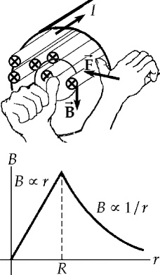

**ANS. FIG. P29.20**

The field is proportional to *r*, as shown in ANS. FIG. P29.20. This field points tangent to a circle of radius *r* and exerts a force  on the wire toward the center of the bundle. The magnitude of the force is



(a) 

(b) Referring to the figure, the field is clockwise, so at the position of the wire, the field is downward, and the force is .

(c) *B* ∝ *r*, so *B* is greatest at the outside of the bundle. Since each wire carries the same current, *F* is 

**P29.21** (a) In , the field will be one-tenth as large at a ten-times larger distance: 

(b) 

so 

(c) Call *r* the distance from cord center to field point and   
2*d* = 3.00 mm the distance between conductors.





so 

The field of the two-conductor cord is weak to start with and falls off rapidly with distance.

(d) The cable creates  field at exterior points, since a loop in Ampère’s law encloses zero total current. Shall we sell coaxial-cable power cords to people who worry about biological damage from weak magnetic fields

**P29.22** Take a circle of radius *r*1 or *r*2 to apply  where for non uniform current density  In this case is parallel to and the direction of *J*is straight through the area element *dA*, so Ampère’s law gives



(a) For *r*1 < *R*,



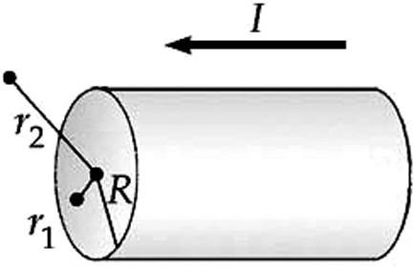 **ANS. FIG. P29.22**

and 

(b) For *r*2 > *R*,



and 

Section 29.4 The Magnetic Field of a Solenoid

**P29.23** The magnetic field at the center of a solenoid is  so



**P29.24** The magnetic field inside of a solenoid is  Thus, the number of turns on this solenoid must be



**\*P29.25** **Conceptualize** Be sure you understand the material in Section 29.4. In order to maximize the magnetic field, we wish to maximize the number of turns of wire on the solenoid.

**Categorize** This problem will involve the evaluation of the magnetic field of a solenoid.

**Analyze** Begin with Equation 29.17:

 (1)

The number *N* of turns depends on the length *L* of the wire and the radius of the solenoid:

 (2)

Substitute Equation (2) into Equation (1):

 (3)

Use Equation 26.7 to replace the current *I* and then Equation 26.10 to evaluate the resistance of the wire:



Substitute numerical values:



**Finalize** Notice that we never had to think about how many layers of wire to use to build the solenoid. If we double the length of wire used in order to use two layers, we double the resistance and halve the current. So there is no advantage to using multiple layers! Another consideration, however, that must be addressed is the power going into the solenoid. Will the wire become too hot and pose a danger to the laboratory in which the solenoid is used? That is a question that we will not address in detail here, but it is one that you can answer with what we have discussed so far in this text.

*Answer:* 5.96 × 10–2 T

**P29.26** In the expression  for the field within a solenoid with radius much less than 20 cm, all we want to do is increase *N*.

(a) Make the wire as long and thin as possible without melting when it carries the 5-A current. Then the solenoid can have many turns.

(b) As small in radius as possible with your experiment fitting inside. Then with a smaller circumference the wire can form a solenoid with more turns.

Section 29.5 Gauss’s Law in Magnetism

**P29.27** (a) The magnetic flux through the flat surface *S*1 is



(b) The net flux out of the closed surface is zero: 

Therefore,



**\*P29.28 Conceptualize** Consider the magnetic field lines in Figure 29.18. This figure suggests the direction of the field lines requested in this problem. But the field in Figure 29.18 is *uniform*. The field requested in this problem is not uniform; it increases in magnitude with vertical position *y*.

**Categorize** Any magnetic field must obey Gauss’s law for magnetism. So let’s categorize the problem as a Gauss’s law problem.

**Analyze** The requested field must be of the form

 (1)

where *B*0 is the value of the field at *y* = 0 and *a* is a constant. Let’s test this field for a cylindrical Gaussian surface just inside the interior surfaces of the proposed chamber. We write Gauss’s law for magnetism:

 (2)

In this integral, the curved sides of the Gaussian surface will not contribute because the magnetic field is perpendicular to every area element. At the ends of the cylindrical Gaussian surface, the field is uniform across the area and directed parallel or antiparallel to the area vectors. Therefore, the integral becomes



where *h* is the height of the cylinder. None of the factors in the evaluation of the integral is zero, so the value of the integral is *not* zero. This violates Gauss’s law for magnetism, so the requested magnetic field is impossible.

**Finalize** One could also argue the impossibility of the field from the statement of Gauss’s law for magnetism that magnetic field lines form closed loops and some geometric logic. Therefore, magnetic field lines cannot originate within the chamber. The only way for the magnetic field magnitude to increase with height is for the density of field lines to increase. This would require that the field lines bunch more closely together as one moves up the chamber. But to do this, the field lines would have to be at an angle to the axis of the device. This is inconsistent with the requirement in the problem that the field lines all be in the axial direction. Therefore, the requested field is impossible.

*Answer:* See solution.

**P29.29** (a)  where *A* is the cross-sectional area of the solenoid. Then,



(b) 



Section 29.6 Magnetism in Matter

**P29.30** (a) The Bohr magneton is



The number of unpaired electrons is



(b) Each iron atom has two unpaired electrons, so the number of iron atoms required is



Thus,



Additional Problems

**P29.31** The magnetic field inside of a solenoid is  Thus, the current in this solenoid must be



**P29.32** Use Equation 29.7 to find the field at a distance from a current loop equal to the radius of the loop:



Solve for the current:



Let *a* be the radius of the Earth and substitute numerical values:



This current would instantly vaporize any wire of reasonable size. For example, if we imagine a 1.00-m segment of copper wire 10 cm in diameter, a *huge* wire, this current delivers over a terawatt of power to this short segment! Furthermore, the power delivered to such a wire wrapped around the Earth is on the order of 1020 W, which is larger than all of the solar power delivered to the Earth by the Sun.

**P29.33** (a) Suppose you have two 100-W headlights running from a 12-V battery, with the whole  current going through the switch 60 cm from the compass. Suppose the dashboard contains little iron, so  Model the current as being from a long, straight wire. Then,

**

(b) If the local geomagnetic field is 5 × 10–5 T, this is  enough to affect the compass noticeably.

**P29.34** Consider a longitudinal filament of the strip of width *dr* as shown in the sketch. The contribution to the field at point *P* due to the current *dI* in the element *dr* is



where . Then,



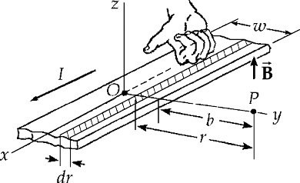

**ANS. FIG. P29.34**

**P29.35** On the axis of a current loop, the magnetic field is given by



where in this case  The magnetic field is directed away from the center, with a magnitude of



**P29.36** On the axis of a current loop, the magnetic field is given by



where in this case  Therefore,



when  then



**P29.37** In ANS FIG. P29.37 (a), the upper sheet acts as conventional current to the right. Consider a patch of the sheet of width *w* parallel to the *z* axis and length *d* parallel to the *x* axis. The charge on it,  passes a point in time interval  so the current it constitutes is  and the linear current density is 

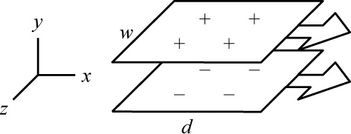

**ANS. FIG. P29.37 (a)**

We may use Ampere’s law to find the magnitude of the magnetic field produced by a sheet because of the translational symmetry along the *z* axis. In ANS. FIG. P29.37 (b), we look at the upper sheet as it approaches us: the upper sheet (and *z*-axis) lies in a horizontal plane and the conventional current is out of the page. Choose a closed rectangular path of width *w* centered about the upper sheet. Because the current it out on the page, we expect the field to point to the right below the sheet and to the left above the sheet.

For the loop, the term  is non-zero along the sides parallel to the sheet and zero along the sides perpendicular to the sheet. From Ampere’s law, we find the magnitude of the magnetic field on either side of the sheet:



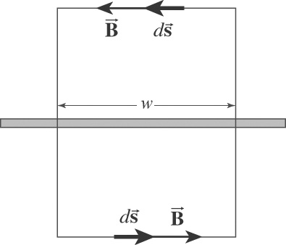

**ANS. FIG. P29.37 (b)**

Therefore, the upper sheet creates field  above it and  below it. Similarly, the lower sheet in its motion toward the right constitutes conventional current toward the left. It creates magnetic field  above it and  below it.

(a) Between the plates, their fields add to



(b) Above both sheets and below both, their equal-magnitude fields add to .

(c) The upper plate exerts no force on itself. The field of the lower plate,  will exert a force on the current in the *w* by *d* section, given by



The force per area is



(d) The electrical force on our section of the upper plate is



The electrical force per area is  To have  we require



**P29.38** (a) Use Equation 29.7 twice for the field created by a current loop



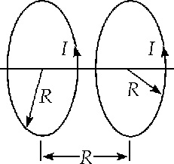

**ANS. FIG. P29.38**

If each coil has *N* turns, the field is just *N* times larger.





(b) 

Substituting  and canceling terms, .



Again substituting  and canceling terms, .

**P29.39** We have a pair of Helmholtz coils whose separation distance is equal to their radius *R*. To find the magnetic field halfway between the coils on their common axis, we use Equation 29.7 to find the field produced on the axis of a loop the distance *x = R*/2 from its center:

 for 1 turn

For *N* turns in each coil,

**P29.40** Model the two wires as straight parallel wires (!). From the treatment of this situation in the chapter text (refer to Equation 29.12), we have

(a) 



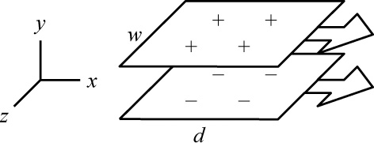

**ANS. FIG. P29.40**

(b) 

(c) The acceleration of the upper loop is found from Newton’s second law:





**P29.41** (a) In , the moving charge constitutes a bit of current as in *I* = *nqvA*. For a positive charge the direction of  is the direction of , so . Next, *A* (*ds*) is the volume occupied by the moving charge, and *nA* (*ds*) = 1 for just one charge. Then,



(b) The magnitude of the field is



(c) The magnetic force on a second proton moving in the opposite direction is



(d) The electric force on a second proton moving in the opposite direction is





**P29.42** (a) 

(b) Because current is diverted through the bar, only half of each rail carries current, so the field produced by each rail is half what an infinitely long wire produces.

Therefore, at point *C*, conductor *AB* produces a field

, 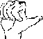   
conductor *DE* produces a field of , 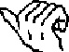 *BD* produces no field, and *AE* produces negligible field. The total field at *C* is 

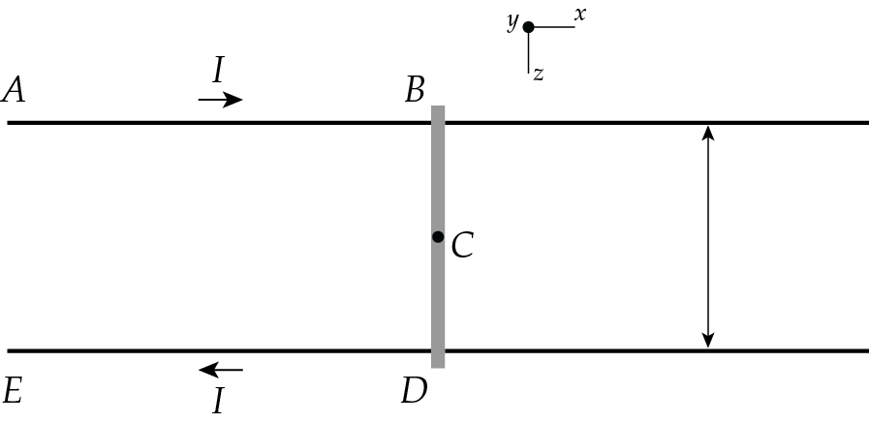



**ANS. FIG. P29.42**

(c) 

The force on the bar is



The field has magnitude

(d)  in the

(e) 

(f) The bar is already so far from *AE* that it moves through nearly constant magnetic field.  


(g) The acceleration is 



so 

**P29.43** Each turn creates a field of  at the center of the coil. In all, they create the field



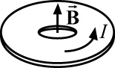

**ANS. FIG. P29.43**

Using a spreadsheet to calculate the sum, we have



Therefore, 

**P29.44** The central wire creates field  counter clockwise. The curved portions of the loop feel no force since  there. The straight portions both feel  forces to the right, amounting to



Challenge Problems

**P29.45** (a) Let the axis of the solenoid lie along the *y* axis from  to *y* = 0. We will determine the field at position *y* = *x*: this point will be inside the solenoid if  and outside if  or *x* > 0. We think of solenoid as formed of rings, each of thickness *dy*. Now *I* is the symbol for the current in each turn of wire and the number of turns per length is . So the number of turns in the ring is  and the current in the ring is  Now, we use Equation 29.7 for the field created by one ring:



where *x* – *y* is the distance from the center of the ring, at location *y*, to the field point (note that *y* is negative, so *x* – *y* = *x* + |*y*|). Each ring creates a field in the same direction, along the *y* axis, so the whole field of the solenoid is



To perform the integral we change variables to *u* = *x* – *y* and *dy* = –*du.* Then,



and then using the table of integrals in the appendix,



(b) If  is much larger than *a* and *x* = 0, we have



This is just half the magnitude of the field deep within the solenoid. We would get the same result by substituting  to describe the other end.

**P29.46** Consider first a solid cylindrical rod of radius *R* carrying current toward you, uniformly distributed over its cross-sectional area. To find the field at distance *r* from its center we consider a circular loop of radius *r*:



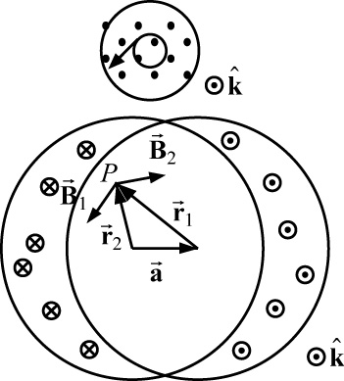

**ANS. FIG. P29.46**

Now the total field at *P* inside the saddle coils is the field due to a solid rod carrying current toward you, centered at the head of vector , plus the field of a solid rod centered at the tail of vector  carrying current away from you.



Now note . Then,



**P29.47** (a) From the shape of the wire,



and so we have



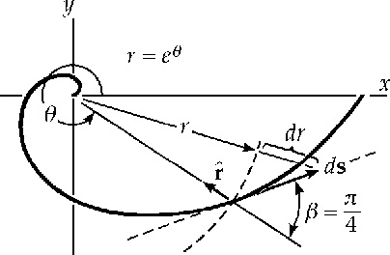

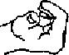

**ANS. FIG. P29.47**

(b) At the origin, there is no contribution from the straight portion of the wire since . For the field contribution from the spiral, refer to the figure. The direction of  is out of the page. The magnitude  because the angle between  and  is always 180° – 45° = 135° = 3*π*/4.

Also, from the figure,



The contribution to the magnetic field is then



The total magnetic field is



Substitute : * *

**P29.48** (a) Consider the sphere as being built up of little spinning ring elements of radius *r*, thickness *dr*, and height *dx*, centered on the rotation axis. Each ring holds charge *dQ*:



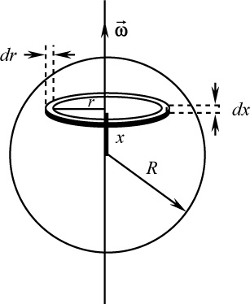

**ANS. FIG. P29.48**

Each ring, with angular speed *ω*, takes a period  to complete one rotation. Thus, each ring carries current



The contribution of each ring element to the magnetic field at a point on the rotation axis a distance *x* from the center of the sphere is given by Equation 29.7:



Combining the above terms, the field contribution is of a ring element is



The contributions of all rings gives



To evaluate the integral, let *v* = *r*2 + *x*2, *dv* = 2*rdr*, and *r*2 = *v* – *x*2.



(b) From part (a), the current associated with each rotating ring of charge is

**

The magnetic moment contributed by this ring is

**

The total magnetic moment is







**P29.49** Note that the current *I* exists in the conductor with a current density , where



Therefore .

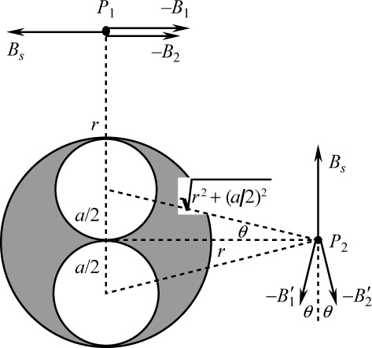

**ANS. FIG. P29.49**

To find the field at either point *P*1 or *P*2, find *Bs* which would exist if the conductor were solid, using Ampère’s law. Next, find *B*1 and *B*2 that *would* be due to the conductors of radius  that *could* occupy the void where the holes exist. Then use the superposition principle and subtract the field that would be due to the part of the conductor where the holes exist from the field of the solid conductor.

(a) At point *P*1,

, , and 



(b) At point *P*2,

 and 

The horizontal components of  and  cancel while their vertical components add.



**P29.50** By symmetry of the arrangement, the magnitude of the net magnetic field at point *P* is *BP* = 8*B*0*x* where *B*0 is the contribution to the field due to current in an edge length equal to . In order to calculate *B*0, we use the Biot-Savart law and consider the plane of the square to be the *yz* plane with point *P* on the *x*-axis. The contribution to the magnetic field at point *P* due to a current element of length *dz* and located a distance *z* along the axis is given by the integral form of the Biot-Savart law as



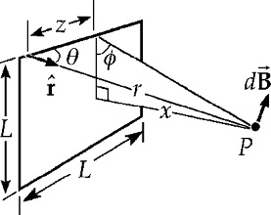

**ANS. FIG. P29.50**

From ANS. FIG. P29.50 we see that

and 

By symmetry all components of the field  at *P* cancel except the components along *x* (perpendicular to the plane of the square); and

 where 

Therefore,



and at *P*, *BP* = 8*B*0*x*.

Using the expressions given above for sin*θ*, cos*φ*, and *r*, we find



Therefore,



**P29.51** (a) From Equation 29.9, the magnetic field produced by one loop at the center of the second loop is given by



where the magnetic moment of either loop is . Therefore,



(b) 

|  |
| --- |
| **ANSWERS TO QUICK-QUIZZES** |

1. B > C > A

2. (a)

3. c > a > d > b

4. a = c = d > b = 0

5. (c)

|  |
| --- |
| **ANSWERS TO EVEN-NUMBERED PROBLEMS** |

**P29.2** (a) 4.06 × 10–6 T (b) The error was caused by the operator of the compass by taking a reading under a power line, and is not caused by a defect in the compass.

**P29.4** 

**P29.6** See ANS. FIG. P29.6

**P29.8** (a) at *y* = –0.420 m; (b) ; (c) 

**P29.10** (a) ; (b) stronger

**P29.12** (a) 8.00 A; (b) opposite directions; (c) force of interaction would be attractive and the magnitude of the force would double

**P29.14** (a) The situation is possible in just one way; (b) 12.0 cm to the left of wire 1; (c) 2.40 A down

**P29.16** This is the required center-to-center separation distance of the wires, but the wires cannot be this close together. Their minimum possible center-to-center separation distance occurs if the wires are touching, but this value is 2*r* = 2(25.0 *μ*m) = 50.0 *μ*m, which is much larger than the required value above. We could try to obtain this force between wires of smaller diameter, but these wires would have higher resistance and less surface area for radiating energy. It is likely that the wires would melt very shortly after the current begins.

**P29.18** 500 A

**P29.20** (a) 6.34 × 10–3 N/m; (b) inward toward the center of the bundle;   
(c) greatest at the outer surface

**P29.22** (a) ;  
(b) 

**P29.24** 4.77 × 104 turns

**P29.26** (a) Make the wire as long and thin as possible without melting when it carries the 5-A current; (b) As small in radius as possible with your experiment fitting inside. Then with a smaller circumference, the wire can form a solenoid with more turns.

**P29.28** See 29.28 for full explanation.

**P29.30** (a)  (b) 

**P29.32** This current would instantly vaporize any wire of reasonable size. For example, if we imagine a 1.00-m segment of copper wire 10 cm in diameter, a *huge* wire, this current delivers over a terawatt of power to this short segment! Furthermore, the power delivered to such a wire wrapped around the Earth is on the order of 1020 W, which is larger than all of the solar power delivered to the Earth by the Sun.

**P29.34 **

**P29.36** 

**P29.38** (a) ; (b) ,  .

**P29.40** (a) 2.46 N upward; (b) Equation 29.7 is the expression for the magnetic field produced a distance *x* above the center of a loop. The magnetic field at the center of the loop or on its axis is much weaker than the magnetic field just outside the wire. The wire has negligible curvature on the scale of 1 mm, so we model the lower loop as a long straight wire to find the field it creates at the location of the upper wire; (c) 107 m/s2 upward

**P29.42** (a) 2.74 × 10–4 T; (b) ; (c) Under the assumption that the rails are infinitely long, the length of rail to the left of the bar does not depend on the location of the bar; (d) 1.15 × 10–3 N; (e) +*x* direction;   
(f) Yes, length of the bar, current, and field are constant, so force is constant; (g) 

**P29.44** 

**P29.46** See P29.46 for full explanation.

**P29.48** (a) ; (b) 

**P29.50** See P29.50 for full explanation.